**Task No. 1:**

Q. Create an array of length 10 of integers. Values ranging from 1 to 50.

1. Find all pair of elements whose sum is 25.

**Solution:**

class Program

{

static void printpairs(int[] arr,

int sum)

{

HashSet<int> s = new HashSet<int>();

for (int X = 0; X < arr.Length; ++X)

{

int temp = sum - arr[X];

// checking for condition

if (s.Contains(temp))

{

Console.Write("Pair with given sum " + sum + " is (" + arr[X] + ", " + temp + ")");

Console.Write("\n\n");

}

s.Add(arr[X]);

}

}

static void Main(string[] args)

{

int[] arr1 = new int[10];

int i , n;

Console.Write("Input the number of elements to be stored in the array :");

n = Convert.ToInt32(Console.ReadLine());

Console.Write("Input {0} elements in the array :\n", n);

for (i = 0; i < n; i++)

{

Console.Write("element - {0} : ", i);

arr1[i] = Convert.ToInt32(Console.ReadLine());

}

int m = 25;

printpairs(arr1, m);

}

}

}

**Output:**

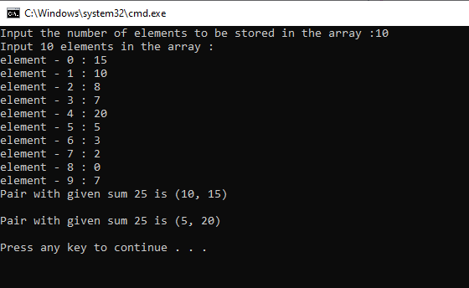

**Task No.2:**

Find the number of elements of A which are even, and the number of elements of A which are odd.

**Solution:**

class Program

{

static void Main(string[] args)

{

int[] arr1 = new int[10];

int[] arr2 = new int[10];

int[] arr3 = new int[10];

int i,j=0,k=0,n;

Console.Write("Input the number of elements to be stored in the array :");

n = Convert.ToInt32(Console.ReadLine());

Console.Write("Input {0} elements in the array :\n",n);

for(i=0;i<n;i++)

{

Console.Write("element - {0} : ",i);

arr1[i] = Convert.ToInt32(Console.ReadLine());

}

for(i=0;i<n;i++)

{

if (arr1[i]%2 == 0)

{

arr2[j] = arr1[i];

j++;

}

else

{

arr3[k] = arr1[i];

k++;

}

}

Console.Write("\nThe Even elements are : \n");

for(i=0;i<j;i++)

{

Console.Write("{0} ",arr2[i]);

}

Console.Write("\nThe Odd elements are :\n");

for(i=0;i<k;i++)

{

Console.Write("{0} ", arr3[i]);

}

Console.Write("\n\n");

}

}

}

**Output:**

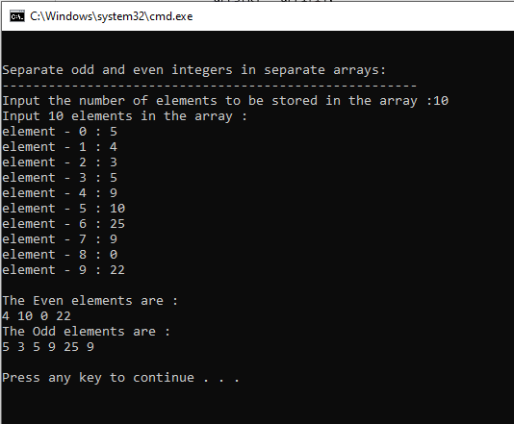

**Task No. 3:**

Write a procedure which finds the average of the value of A

**Solution:**

class Program

{

static void Main(string[] args)

{

int[] arr1 = new int[10];

int[] arr2 = new int[10];

int[] arr3 = new int[10];

int i, n;

Console.Write("Input the number of elements to be stored in the array :");

n = Convert.ToInt32(Console.ReadLine());

Console.Write("Input {0} elements in the array :\n", n);

for (i = 0; i < n; i++)

{

Console.Write("element - {0} : ", i);

arr1[i] = Convert.ToInt32(Console.ReadLine());

}

int sum = 0;

int average = 0;

for ( i = 0; i < n; i++)

{

sum += arr1[i];

}

average = sum / n;

Console.WriteLine("Sum Of Array is : " + sum);

Console.WriteLine("Average Of Array is : " + average);

Console.ReadLine();

}

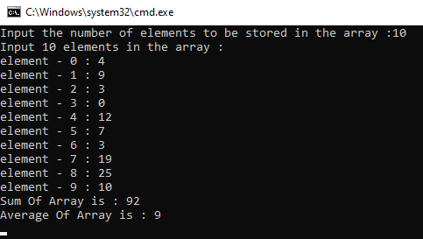 }

}

**Output:**

**Task No. 4:**

Write a procedure which adds an element in an array at a given index. Take the value to add and the index from the user by using Shift down technique.

**Solution:**

class Program

{

static void Main(string[] args)

{

int[] arr = new int[12];

Console.WriteLine("Initial Array is : ");

for (int i = 1; i < arr.Length -1; i++)

{

arr[i] = i;

Console.Write(arr[i] + " ");

}

int index = 5;

for (int j = 0; j <= index; j++)

{

arr[j] = arr[j + 1];

}

arr[index] = 25;

Console.WriteLine("\n");

Console.WriteLine("Array after putting value at desired index is : ");

for (int i = 0; i < arr.Length - 1; i++)

{

Console.Write(arr[i] + " ");

}

Console.Read();

}

}

}

**Output:**

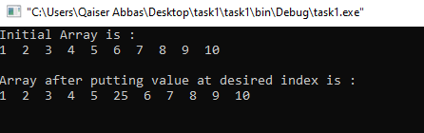

**Task No. 5:**

Write a procedure which looks for 2 numbers 45 and 14 in an array and delete them if they are present in the array by using Shift up technique.

**Solution:**

class Program

{

static void Main(string[] args)

{

int[] array = new int[10] { 2, 9, 45, 5, 14, 1, 7, 10, 33, 3 };

int counter = 0;

for (int i = 0; i < array.Length; i++)

{

Console.WriteLine(array[i]);

}

for (int i = 0; i < array.Length; i++)

{

if ((array[i] != 14) && (array[i] != 45))

{

counter++;

Console.WriteLine("index {0} Enement Value is {1} ", counter - 1, array[i]);

}

}

}

}

**Output:**

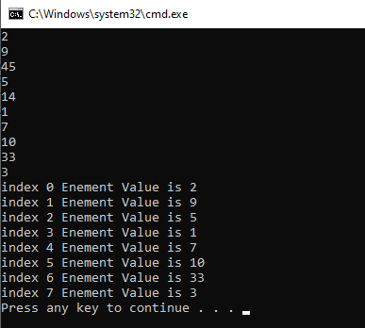

**2D ARRAYS**

1. Write a program which input 2 matrix of user defined rows and columns and perform following operation

* **Display/Print as a Matrix**

class Program

{

static void Main(string[] args)

{

int i, j, n;

int[,] arr1 = new int[5, 5];

int[,] brr1 = new int[5, 5];

int[,] crr1 = new int[5, 5];

Console.Write("Input the size of the square matrix: ");

n = Convert.ToInt32(Console.ReadLine());

Console.Write("Input elements in the first matrix :\n");

for (i = 0; i < n; i++)

{

for (j = 0; j < n; j++)

{

Console.Write("element - [{0},{1}] : ", i, j);

arr1[i, j] = Convert.ToInt32(Console.ReadLine());

if (arr1[i, j] < 0 || arr1[i, j] > 50)

{

Console.WriteLine("No out of range");

}

}

}

Console.Write("Input elements in the second matrix :\n");

for (i = 0; i < n; i++)

{

for (j = 0; j < n; j++)

{

Console.Write("element - [{0},{1}] : ", i, j);

brr1[i, j] = Convert.ToInt32(Console.ReadLine());

if (brr1[i, j] < 0 || brr1[i, j] > 50)

{

Console.WriteLine("No out of range");

}

}

}

Console.Write("\nThe First matrix is :\n");

for (i = 0; i < n; i++)

{

Console.Write("\n");

for (j = 0; j < n; j++)

Console.Write("{0}\t", arr1[i, j]);

}

Console.Write("\nThe Second matrix is :\n");

for (i = 0; i < n; i++)

{

Console.Write("\n");

for (j = 0; j < n; j++)

Console.Write("{0}\t", brr1[i, j]);

}

}

}

**Output:**

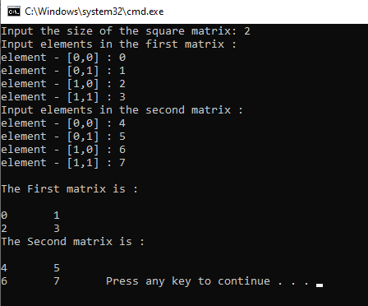

**TASK#1[b]**

* **Addition of Matrix**

class Program

{

static void Main(string[] args)

{

int i, j, n;

int[,] arr1 = new int[50, 50];

int[,] brr1 = new int[50, 50];

int[,] crr1 = new int[50, 50];

Console.Write("Input the size of the square matrix: ");

n = Convert.ToInt32(Console.ReadLine());

Console.Write("Input elements in the first matrix :\n");

for (i = 0; i < n; i++)

{

for (j = 0; j < n; j++)

{

Console.Write("element - [{0},{1}] : ", i, j);

arr1[i, j] = Convert.ToInt32(Console.ReadLine());

}

}

Console.Write("Input elements in the second matrix :\n");

for (i = 0; i < n; i++)

{

for (j = 0; j < n; j++)

{

Console.Write("element - [{0},{1}] : ", i, j);

brr1[i, j] = Convert.ToInt32(Console.ReadLine());

}

}

Console.Write("\nThe First matrix is :\n");

for (i = 0; i < n; i++)

{

Console.Write("\n");

for (j = 0; j < n; j++)

Console.Write("{0}\t", arr1[i, j]);

}

Console.Write("\nThe Second matrix is :\n");

for (i = 0; i < n; i++)

{

Console.Write("\n");

for (j = 0; j < n; j++)

Console.Write("{0}\t", brr1[i, j]);

}

/* calculate the sum of the matrix */

for (i = 0; i < n; i++)

for (j = 0; j < n; j++)

crr1[i, j] = arr1[i, j] + brr1[i, j];

Console.Write("\nThe Addition of two matrix is : \n");

for (i = 0; i < n; i++)

{

Console.Write("\n");

for (j = 0; j < n; j++)

Console.Write("{0}\t", crr1[i, j]);

} Console.Write("\n\n");

}

}

}

**Output:**

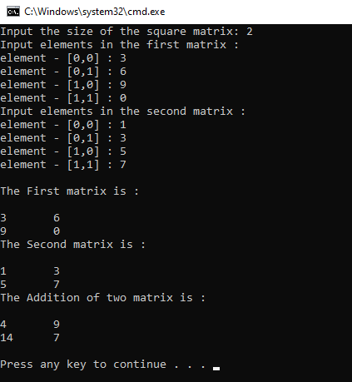

**TASK#1[c]**

* **Subtraction of Matrix**

class Program

{

static void Main(string[] args)

{

int i, j, n;

int[,] arr1 = new int[50, 50];

int[,] brr1 = new int[50, 50];

int[,] crr1 = new int[50, 50];

Console.Write("Input the size of the square matrix: ");

n = Convert.ToInt32(Console.ReadLine());

Console.Write("Input elements in the first matrix :\n");

for (i = 0; i < n; i++)

{

for (j = 0; j < n; j++)

{

Console.Write("element - [{0},{1}] : ", i, j);

arr1[i, j] = Convert.ToInt32(Console.ReadLine());

}

}

Console.Write("Input elements in the second matrix :\n");

for (i = 0; i < n; i++)

{

for (j = 0; j < n; j++)

{

Console.Write("element - [{0},{1}] : ", i, j);

brr1[i, j] = Convert.ToInt32(Console.ReadLine());

}

}

Console.Write("\nThe First matrix is :\n");

for (i = 0; i < n; i++)

{

Console.Write("\n");

for (j = 0; j < n; j++)

Console.Write("{0}\t", arr1[i, j]);

}

Console.Write("\nThe Second matrix is :\n");

for (i = 0; i < n; i++)

{

Console.Write("\n");

for (j = 0; j < n; j++)

Console.Write("{0}\t", brr1[i, j]);

}

/* calculate the subtraction of the matrix */

for (i = 0; i < n; i++)

for (j = 0; j < n; j++)

crr1[i, j] = arr1[i, j] - brr1[i, j];

Console.Write("\nThe Subtraction of two matrix is : \n");

for (i = 0; i < n; i++)

{

Console.Write("\n");

for (j = 0; j < n; j++)

Console.Write("{0}\t", crr1[i, j]);

}

Console.Write("\n\n");

}

}

**Output:**

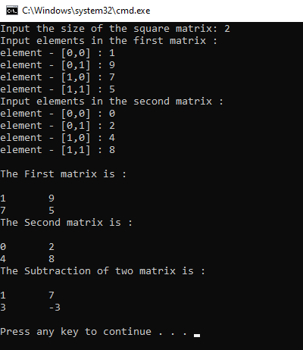

**TASK#1[d]**

* **Matrix multiplication**

class Program

{

static void Main(string[] args)

{

int i, j, n;

int[,] arr1 = new int[50, 50];

int[,] brr1 = new int[50, 50];

int[,] crr1 = new int[50, 50];

Console.Write("Input the size of the square matrix: ");

n = Convert.ToInt32(Console.ReadLine());

Console.Write("Input elements in the first matrix :\n");

for (i = 0; i < n; i++)

{

for (j = 0; j < n; j++)

{

Console.Write("element - [{0},{1}] : ", i, j);

arr1[i, j] = Convert.ToInt32(Console.ReadLine());

}

}

Console.Write("Input elements in the second matrix :\n");

for (i = 0; i < n; i++)

{

for (j = 0; j < n; j++)

{

Console.Write("element - [{0},{1}] : ", i, j);

brr1[i, j] = Convert.ToInt32(Console.ReadLine());

}

}

Console.Write("\nThe First matrix is :\n");

for (i = 0; i < n; i++)

{

Console.Write("\n");

for (j = 0; j < n; j++)

Console.Write("{0}\t", arr1[i, j]);

}

Console.Write("\nThe Second matrix is :\n");

for (i = 0; i < n; i++)

{

Console.Write("\n");

for (j = 0; j < n; j++)

Console.Write("{0}\t", brr1[i, j]);

}

/* calculate the multiplication of the matrix */

for (i = 0; i < n; i++)

for (j = 0; j < n; j++)

crr1[i, j] = arr1[i, j] * brr1[i, j];

Console.Write("\nThe Mutiplication of two matrix is : \n");

for (i = 0; i < n; i++)

{

Console.Write("\n");

for (j = 0; j < n; j++)

Console.Write("{0}\t", crr1[i, j]);

} Console.Write("\n\n");

}

}

}

**Output:**

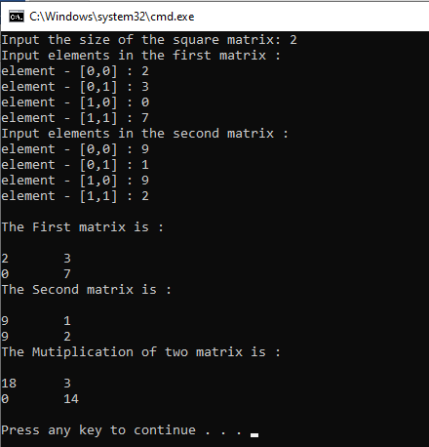

**TASK#1[e]**

* **Determinant**

class Program

{

static void Main(string[] args)

{

int[,] matrix = new int[2, 2];

for (int i = 0; i < 2; i++)

{

for (int j = 0; j < 2; j++)

{

Console.WriteLine("Enter the Value for index [{0},{1}]", i, j);

matrix[i, j] = Convert.ToInt32(Console.ReadLine());

}

}

int c = 0;

Console.WriteLine("--------------------------------");

Console.WriteLine("Taking Determenant");

Console.WriteLine("--------------------------------");

Console.WriteLine("\n");

for (int i = 0; i < 1; i++)

{

for (int j = 0; j < 1; j++)

{

c = matrix[i, j];

}

}

int d = 0;

for (int i = 1; i < 2; i++)

{

for (int j = 1; j < 2; j++)

{

d = matrix[i, j];

}

}

int diagnol1 = d * c;

Console.WriteLine("Diagnol 1 :" + diagnol1);

int e = 0;

for (int i = 0; i < 1; i++)

{

for (int j = 1; j < 2; j++)

{

e = matrix[i, j];

}

}

int f = 0;

for (int i = 1; i < 2; i++)

{

for (int j = 0; j < 1; j++)

{

f = matrix[i, j];

}

}

int diagonal2 = f * e;

Console.WriteLine("Diagnol 2 :" + diagonal2);

Console.WriteLine("--------------------------------");

int determinant = diagnol1 - diagonal2;

Console.WriteLine("Subtact: [Diagnol 1- Diagnol 2] ");

Console.WriteLine("\t = {0} - {1} = {2}", diagnol1, diagonal2, diagnol1 - diagonal2);

Console.WriteLine("--------------------------------");

Console.WriteLine("Determinant: {0}", determinant);

}

}

}

**Output:**

